# Multithreading – Thread Creation assignments

**Mandatory**

1. Refer the program in “thread_prg.c”. Complete the TBD sections , check the final solution for memory leak if any

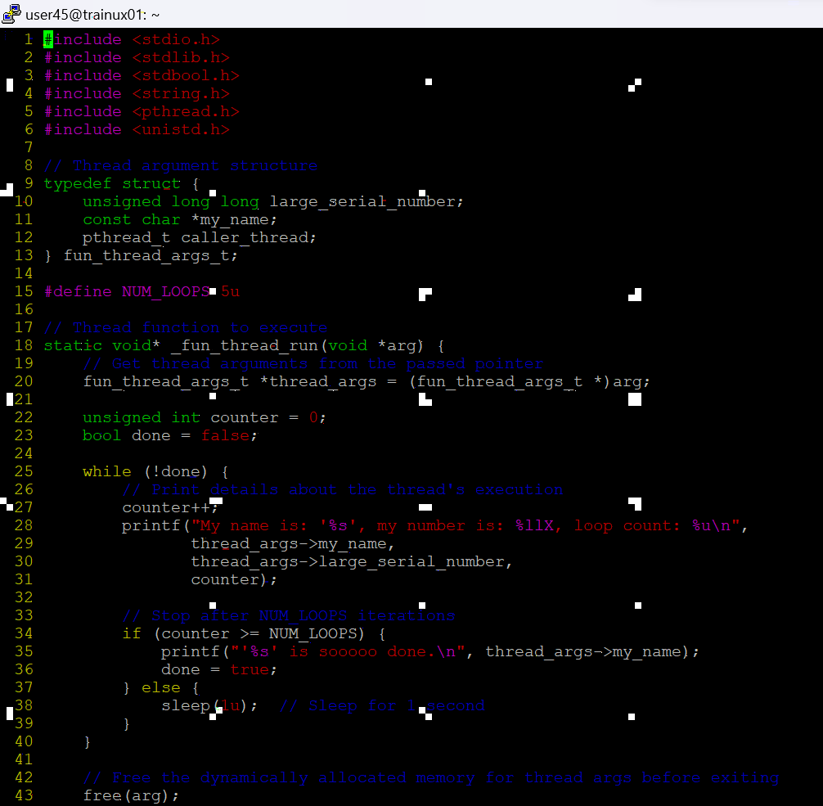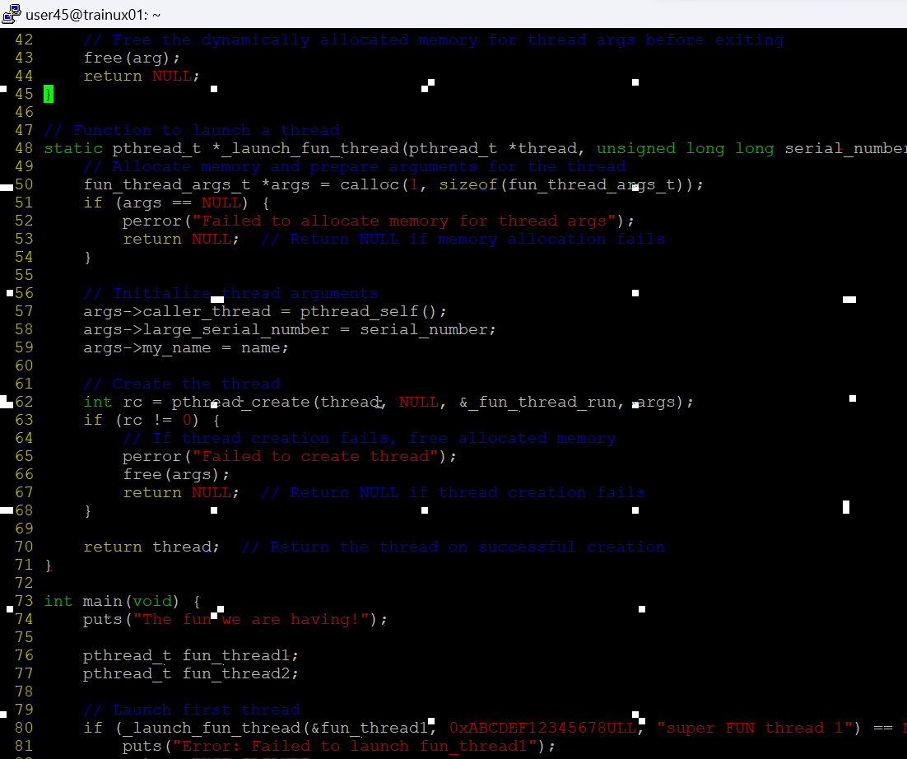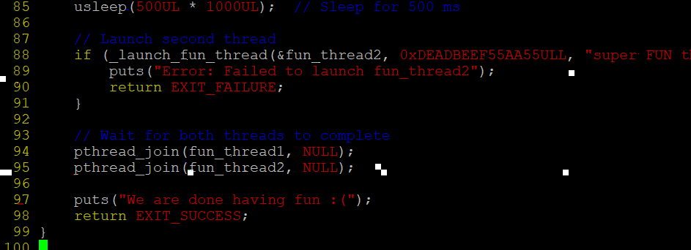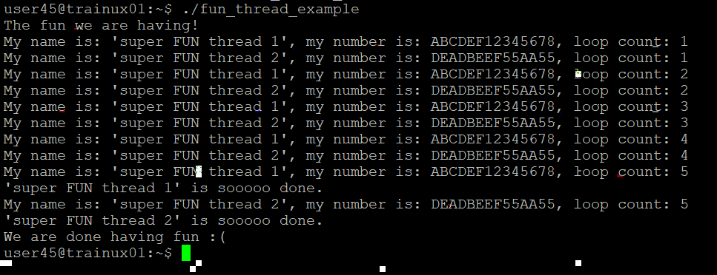

1. Write a program
2. to read a set of words as command line arguments and to create an array of threads (Consider a maximum of 5 words )
3. process each word using an separate thread. Let each thread append “_ed” to the input word and return to main thread
4. main thread to wait for completion of each thread, retrieve returned string display with thread number, free memory

